Application For Renewal of Port Conveyance Permit

- Kindly fill up the application form below.
- Email the completed application form to syafiq@penangport.gov.my and zulkeffli@penangport.gov.my
- The supporting documents and permit book shall be submitted on the same day of the email sent to SPPP.
- The notification regarding the approval, total fee and collection date of the permit book will made via email.
- The applicant is required to make payment before collecting the permit book.

Supporting documents:

(i) Permit Book;
(ii) International Load Line Certificate; or
(iii) Certificate of Malaysian Registry.

Application for Port Conveyance Permit (New Application)

- Kindly fill up the application form below.
- Email the completed application form to syafiq@penangport.gov.my and zulkeffli@penangport.gov.my
- The supporting documents and permit book shall be submitted on the same day of the email sent to SPPP.
- The notification regarding the approval, total fee and collection date of the permit book will made via email.
- The applicant is required to make payment before collecting the permit book.

Supporting documents:

(ii) International Load Line Certificate; or
(iii) Certificate of Malaysian Registry.

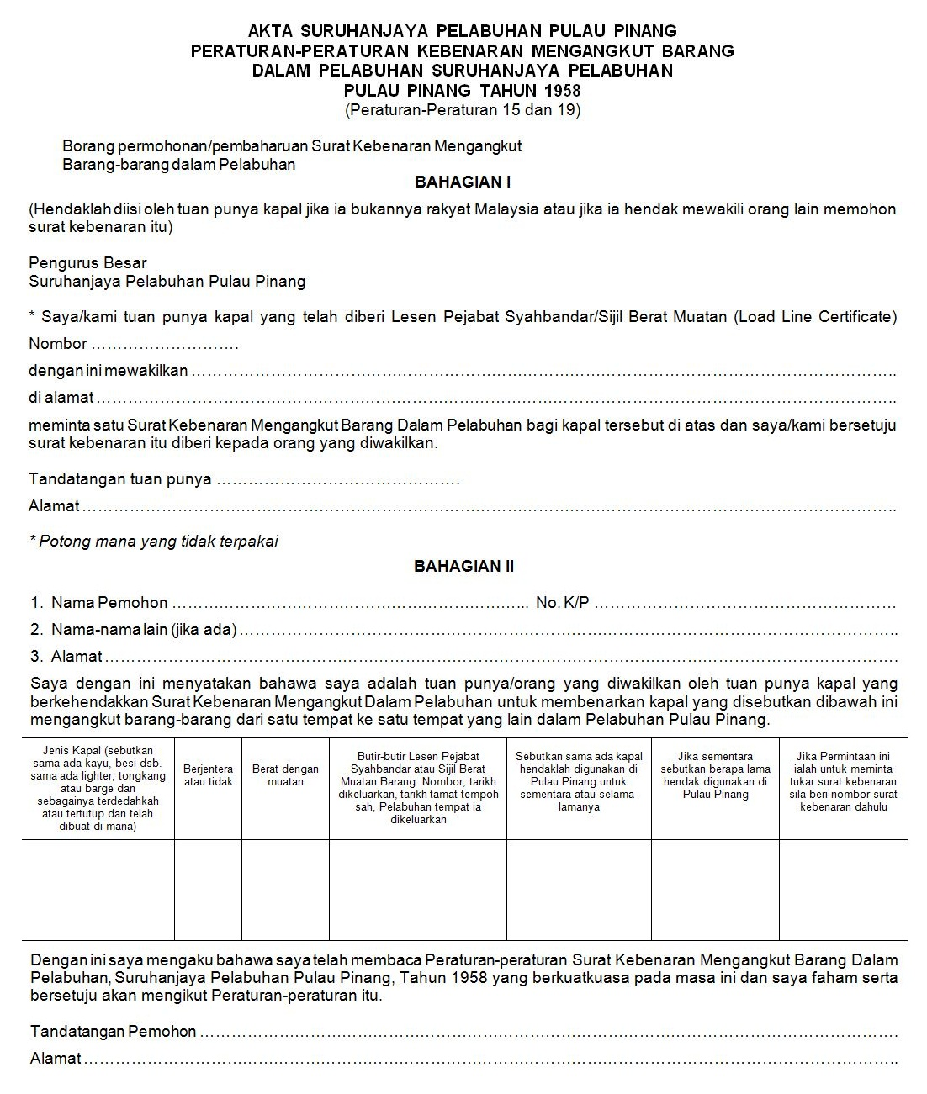
Sila isikan maklumat anda di sini

Sila isikan maklumat anda di sini

Sila isikan maklumat anda di sini

Sila isikan maklumat anda di sini

Sila isikan maklumat anda di sini

Sila isikan maklumat anda di sini

Sila isikan maklumat anda di sini

Sila isikan maklumat anda di sini

Sila isikan maklumat anda di sini

Sila isikan maklumat anda di sini

Sila isikan maklumat anda di sini

Sila isikan maklumat anda di sini

Sila isikan maklumat anda di sini

Sila isikan maklumat anda di sini

Sila isikan maklumat anda di sini

Sila isikan maklumat anda di sini

Berjentera atau Tidak Berjentera

Sila isikan maklumat anda di sini

No. XXXX

